**Malena - Presentation Contribution**

**This portion of the repo provides references for the presentation.**

**VLAN Implementation**

* Create VLANs to segregate network traffic based on departments:
  + VLAN 10: 192.168.10.1/24
  + VLAN 20: 192.168.20.1/24
  + VLAN 30: 192.168.30.1/24
  + VLAN 40: 192.168.40.1/24

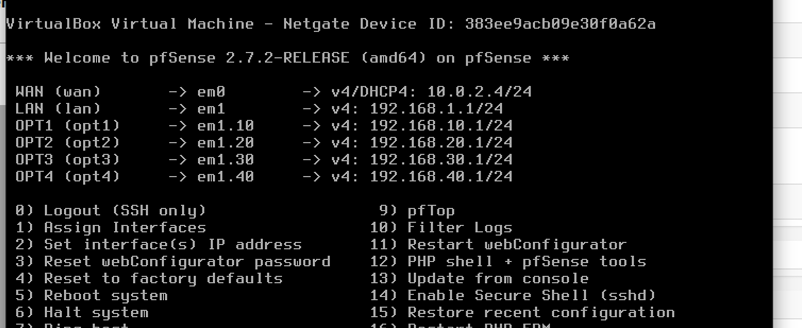

**Virtual Machine Deployment**

* Deploy virtual machines for:
  + Server: Windows Server 2019
  + Router: pfSense
  + Computers: all Windows 10

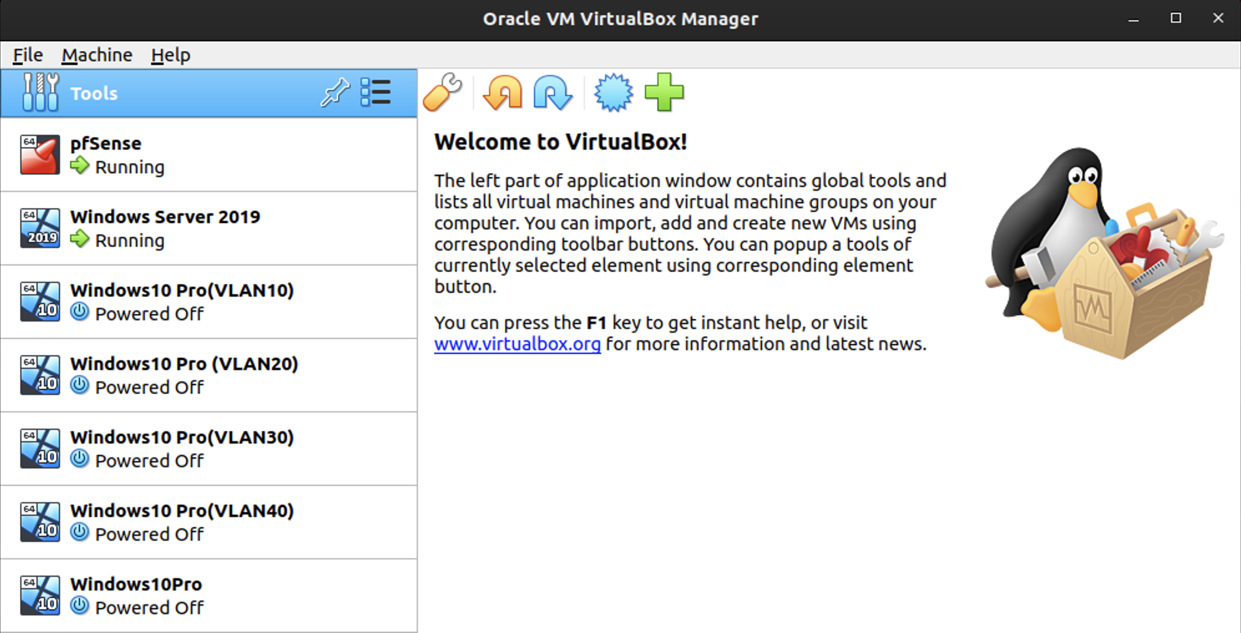

VLANs correspond with department numbers, 10, 20, 30, and 40.

SOP

[Network Traffic Monitoring](https://docs.google.com/document/d/10JZVuiw5yflKhrTEOLs0JRmjNSFClHZK8l6Lx2h9TMg/edit?usp=sharing)

Resources:

* <https://docs.netgate.com/pfsense/en/latest/vlan/configuration.html>
* <https://www.youtube.com/watch?v=mJrvvC-eHAE>
* <https://learn.microsoft.com/en-us/system-center/vmm/vm-template?view=sc-vmm-2022>
* <https://www.techtarget.com/searchitoperations/definition/virtual-machine-VM>